Car Blackbox (Final Project)

Similar to airplane Blackbox. A small device in your car that monitors the metrics (speed, acc, mileage,)

* Event Data Recorded
* Enhances safety standards of the vehicles
* Monitors vehicle performance and driving habits
* AKA Event Data Recorder
* Announces safety standards
* Whatever occurs may be viewed by police and insurance as proof or to help with insurance claims

Will be implemented using PIC SimLab PICGenios which has the following components

Microcontroller, EEPROM, Potentiometer, LEDS, LCD, Heater, Cooler, Buttons, SSD(Seven Segment Display)

The Project will have:

1. Default Screen/ Device Dashboard:

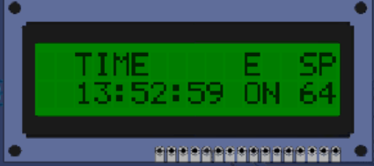

This will be on the LCD. Whenever the device is on this is shown

* 1. Time HH:MM:SS
  2. Event{E} (Current Event): On hers it was ON. Initially this will be ON on device switch on.
     1. Gear shifts are considered as events. Whenever there is a gear shift is is triggered as an event. These gears will be viewed as GN, GR, G1, G2, G3, G4. In this case the two switches (SW2)RB1/INT1 and (SW3)RB2/INT2 for gear switching up and down respectively
     2. On collision the event will show C which is set with (SW1)RB0/INT
  3. Current Speed {SP}
     1. The potentiometer P1-AND is used to vary the speed. Since the speed is 2 digit, the maximum value is 99

Time Event SP

HH:MM:SS E 00

Whenever an event occurs, the program should record the speed, time and event. This involves storing/save theses. This project will have a maximum 10 events stored index start from 0. Event array will be:

Index HH:MM:SS Event Speed

0 07:24:35 ON 00

1 07:30:32 G1 35

…

9 10:30:00 G4 60

At an event after 10, we will over write the earliest event (0)

The events are stored in the internal EEPROM

1. View Previous Logs

To view previous password, the RB4 or RB3 are used to initiate the password request screen:

* 1. It should display:

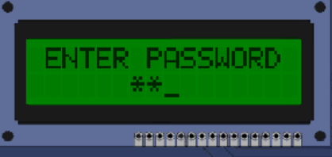

ENTER PASSWORD

****

The user has 3 attempts after which the user must wait 15min

To enter the password, we use (SW4) RB3 and (SW5) RB4 in any 4 input combination which will not show on the screen but rather show asterisk

* 1. Upon successful password entry, the view is view or clear logs/events or change password displayed as:

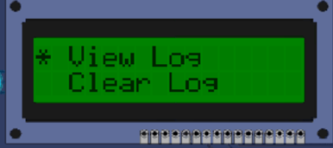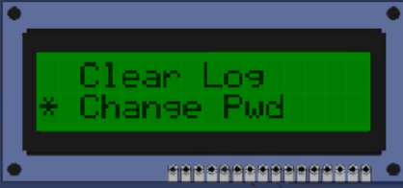

View Logs

Clear Logs

Change Password

Navigation between the options is done using the (SW4) RB3 and (SW5) RB4. To select an option the (SW6)RB5 is used

* + 1. On selecting view logs the SW4 and SW5 is used to move up and down the indices of the events shown as below:

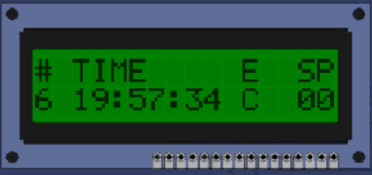 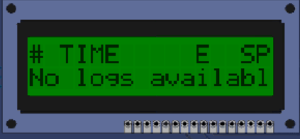

* + - 1. To move back from the view log menu, the switch SW6 is used
    1. Selecting clear logs clears the entries from the list
    2. On selecting change password, it should ask for the new password entered and re-enter password. If both match a prompt will show the password has changed

Enter password

****

Re-enter Password

****

|  |  |  |
| --- | --- | --- |
|  |  |  |
| LCD | LCD | Display |
| SW1  SW2  SW3  SW4  SW5  SW6 | RB0  RB1  RB2  RB3  RB4  RB5 | Collision  Gear Down  Gear Up  Password input and up nav  Password input and down nav  Select nav |
| Potentiometer | P1-AN0 | Acceleration |
| EEPROM | EEPROM | Memory |
| Microcontroller | PIC18F452 | CPU |
| Real time Clock | RTC | Clock |
|  |  |  |